# DESIGN

Main

# Initialize scanner object

# Get input

# Prompt user for subtotal and gratuity

# store value in a String (providedValue)

# Initialize Int: counter, intSubtotal, intGratuity

# Loop through providedValue, separating by a “ “ (space) character

# First value will be intSubtotal

# Second value will be intGratuity

# Increment the counter

# Calculate Double gratuity as the result of intSubtotal * intGratuity / 100

# Gratuity is provided as a whole number, so the division by 100 is to get it to a percentage

# Calculate Double total as intSubtotal + gratuity

# Print output

## Flow Chart

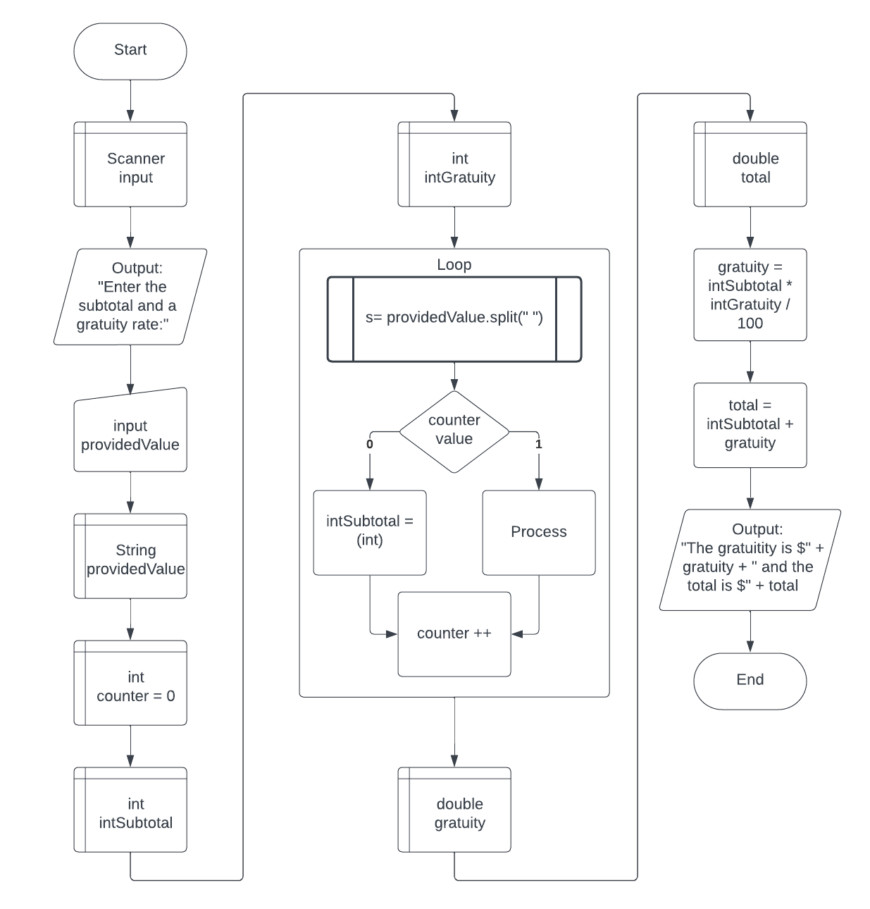

# TEST PLAN

|  |  |  |
| --- | --- | --- |
| Test # | Input | Expected Output |
| 1 | 10 10 | 10.10 |
| 2 | 100 53 | 153.00 |
| 3 | 22 7 | 23.54 |